OPERATING SYSTEMS LAB
LABORATORY MANUAL
B.Tech., Semester -IV
Subject Code: BCS-451


Session: 2023-24, Even Semester
Name:
Roll. No.:
Group/Branch:

JSS MAHAVIDYAPEETHA
DEPARTMENT OF INFORMATION TECHNOLOGY
JSS ACADEMY OF TECHNICAL EDUCATION
C-20/1, SECTOR-62, NOIDA

Table of Contents
- Vision and Mission of the Institute
- Vision and Mission of the Department
- Program Educational Objectives (PEOs)
- Program Outcomes (POs)
- Program Specific Outcomes (PSOs)
- University Syllabus
- Course Outcomes (COs)
- CO- PO and CO-PSO mapping
- Course Overview
- List of Experiments
- DO’s and DON’Ts
- General Safety Precautions
- Guidelines for students for report preparation
- Lab assessment criteria
- Details of Conducted Experiments
- Lab Experiments

Vision and Mission of the Institute
Vision:
“JSS Academy of Technical Education Noida aims to become an Institution of excellence in imparting quality Outcome Based Education that empowers the young generation with Knowledge, Skills, Research, Aptitude and Ethical values to solve Contemporary Challenging Problems”

Mission:
M1: Develop a platform for achieving globally acceptable level of intellectual acumen and technological competence.
M2: Create an inspiring ambience that raises the motivation level for conducting quality research.
M3: Provide an environment for acquiring ethical values and positive attitude.
Vision and Mission of the Department
Vision:
“To become a Centre of Excellence in teaching and research in Information Technology for producing skilled professionals having a zeal to serve society”

Mission:
M1: To create an environment where students can be equipped with strong fundamental concepts, programming and problem solving skills.
M2: To provide an exposure to emerging technologies by providing hands on experience for generating competent professionals.
M3: To promote Research and Development in the frontier areas of Information Technology and encourage students for pursuing higher education
M4: To inculcate in students ethics, professional values, team work and leadership skills.

Programme Educational Objectives (PEOs)
PEO1: To provide students with a sound knowledge of mathematical, scientific and engineering fundamentals required to solve real world problems.
PEO2: To develop research oriented analytical ability among students and to prepare them for making technical contribution to the society.
PEO3: To develop in students the ability to apply state-of-the–art tools and techniques for designing software products to meet the needs of Industry with due consideration for environment friendly and sustainable development.
PEO4: To prepare students with effective communication skills, professional ethics and managerial skills.
PEO5: To prepare students with the ability to upgrade their skills and knowledge for life-long learning.

Programme Outcomes (POs)
PO1: Engineering knowledge: Apply the knowledge of mathematics, science, engineering fundamentals, and an engineering specialization to the solution of complex engineering problems.
PO2: Problem analysis: Identify, formulate, review research literature, and analyze complex engineering problems reaching substantiated conclusions using first principles of mathematics, natural sciences, and engineering sciences.
PO3: Design/development of solutions: Design solutions for complex engineering problems and design system components or processes that meet the specified needs with appropriate consideration for the public health and safety, and the cultural, societal, and environmental considerations.
PO4: Conduct investigations of complex problems: Use research-based knowledge and research methods including design of experiments, analysis and interpretation of data, and synthesis of the information to provide valid conclusions.
PO5: Modern tool usage: Create, select, and apply appropriate techniques, resources, and modern engineering and IT tools including prediction and modeling to complex engineering activities with an understanding of the limitations.
PO6: The engineer and society: Apply reasoning informed by the contextual knowledge to assess societal, health, safety, legal and cultural issues and the consequent responsibilities relevant to the professional engineering practice.
PO7: Environment and sustainability: Understand the impact of the professional engineering solutions in societal and environmental contexts, and demonstrate the knowledge of, and need for sustainable development.
PO8: Ethics: Apply ethical principles and commit to professional ethics and responsibilities and norms of the engineering practice.
PO9: Individual and team work: Function effectively as an individual, and as a member or leader in diverse teams, and in multidisciplinary settings.
PO10: Communication: Communicate effectively on complex engineering activities with the engineering community and with society at large, such as, being able to comprehend and write effective reports and design documentation, make effective presentations, and give and receive clear instructions.
PO11: Project management and finance: Demonstrate knowledge and understanding of the engineering and management principles and apply these to one’s own work, as a member and leader in a team, to manage projects and in multidisciplinary environments.
PO12: Life-long learning: Recognize the need for, and have the preparation and ability to engage in independent and life-long learning in the broadest context of technological change.

Program Specific Outcomes (PSOs)
PSO1: Analyze, identify and clearly define a problem for solving user needs by selecting, creating and evaluating a computer based system through an effective project plan.
PSO2: Design, implement and evaluate processes, components and/or programs using modern techniques, skills and tools of core Information Technologies to effectively integrate secure IT-based solutions into the user environment.
PSO3: Develop impactful IT solutions by using research based knowledge and research methods in the fields of integration, interface issues, security & assurance and implementation.

University Syllabus
1. Study of hardware and software requirements of different operating systems (UNIX,LINUX,WINDOWS XP, WINDOWS7/8
2. Execute various UNIX system calls for i. Process management ii. File management iii. Input/output Systems calls
3. Implement CPU Scheduling Policies: i. SJF ii. Priority iii. FCFS iv. Multi-level Queue
4. Implement file storage allocation technique: i. Contiguous(using array) ii. Linked –list(using linked-list) iii. Indirect allocation (indexing)
5. Implementation of contiguous allocation techniques: i. Worst-Fit ii. Best- Fit iii. First- Fit
6. Calculation of external and internal fragmentation i. Free space list of blocks from system ii. List process file from the system
7. Implementation of compaction for the continually changing memory layout and calculate total movement of data
8. Implementation of resource allocation graph RAG)
9. Implementation of Banker‟s algorithm
10. Conversion of resource allocation graph (RAG) to wait for graph (WFG) for each type of method used for storing graph.
11. Implement the solution for Bounded Buffer (producer-consumer)problem using inter process communication techniques-Semaphores
12. Implement the solutions for Readers-Writers problem using inter process communication technique -Semaphore

Course Outcomes (COs)

C213.1: To compare various CPU scheduling algorithms through simulation.
C213.2: To simulate various synchronization algorithms to achieve mutual exclusion using
Semaphores.
C213.3: Simulate paging technique for memory management.
C213.4: To simulate resource acquisition and release for deadlock handling.
C213.5: Simulate various disk scheduling algorithms.

CO-PO Mapping:
 | PO1 | PO2 | PO3 | PO4 | PO5 | PO6 | PO7 | PO8 | PO9 | PO10 | PO11 | PO12
C213.1 | 1 | 2 | 2 | 2 |  |  |  | 2 | 2 | 2 | 1 | 2
C213.2 | 1 | 2 | 2 | 2 |  |  |  | 2 | 2 | 2 | 1 | 2
C213.3 | 1 | 2 | 2 | 2 |  |  |  | 2 | 2 | 2 | 1 | 2
C213.4 | 1 | 2 | 2 | 2 |  |  |  | 2 | 2 | 2 | 1 | 2
C213.5 | 1 | 2 | 2 | 2 |  |  |  | 2 | 2 | 2 | 1 | 2
C213 | 1 | 2 | 2 | 2 |  |  |  | 2 | 2 | 2 | 1 | 2

CO-PSO Mapping:
 | PSO1 | PSO2 | PSO3
C213.1 | 1 |  | 1
C213.2 | 1 |  | 1
C213.3 | 1 |  | 1
C213.4 | 1 |  | 1
C213.5 | 1 |  | 1
C213 | 1 |  | 1

Course Overview
In Operating Systems lab Students will gain practical experience with designing and implementing concepts of operating systems. Operating system lab complements Operating system Course. In this lab they will understand the basic services and functionalities of the operating system. Students will get the practical exposure on the structure and functions of an operating system, key operating system aspects by concrete example. Students are prepared for future courses.
In this lab students will implement various scheduling algorithm to compare turn-around time and access time, various process synchronization algorithms for preventing deadlocks, Memory Management algorithm for adequate allocation of memory for various concurrent running process. Students will also be able to distinguish paged and segmented virtual memory. Students will learn practical aspects of Processes & Scheduling, Memory Management, I/O & Device Management and filling systems.

List of Experiments mapped with COs
Sl No. | Program Name | Course Outcome
1 | To implement CPU scheduling using the following algorithms:  FIRST COME FIRST SERVE SCHEDULING, SHORTEST JOB FIRST, SHORTEST REMAINING TIME FIRST, PRIORITY SCHEDULING and ROUND ROBIN. | C213.1
2 | To Implement producer consumer problem using semaphores. | C213.2
3 | To implement Dead lock detection and recovery using Banker’s Algorithm. | C213.4
4 | To implement Memory Management Techniques using the following algorithms:  FIRST-FIT, BEST-FIT and WORST- FIT. | C213.3
5 | To implement page replacement techniques using the following algorithms:  FIFO, LRU and OPTIMAL. | C213.3
6 | To Implement Disk Scheduling using the following algorithms:  FCFS, SCAN and C-SCAN. | C213.5

DOs and DON’Ts
DOs
- Login-on with your username and password.
- Log off the Computer every time when you leave the Lab.
- Arrange your chair properly when you are leaving the lab.
- Put your bags in the designated area.
- Ask permission to print.
DON’Ts
- Do not share your username and password.
- Do not remove or disconnect cables or hardware parts.
- Do not personalize the computer setting.
- Do not run programs that continue to execute after you log off.
- Do not download or install any programs, games or music on computer in Lab.
- Personal Internet use chat room for Instant Messaging (IM) and Sites is strictly prohibited.
- No Internet gaming activities allowed.
- Tea, Coffee, Water & Eatables are not allowed in the Computer Lab.
General Safety Precautions
Precautions (In case of Injury or Electric Shock)
- To break the victim with live electric source, use an insulator such as fire wood or plastic to break the contact. Do not touch the victim with bare hands to avoid the risk of electrifying yourself.
- Unplug the risk of faulty equipment. If main circuit breaker is accessible, turn the circuit off.
- If the victim is unconscious, start resuscitation immediately, use your hands to press the chest in and out to continue breathing function. Use mouth-to-mouth resuscitation if necessary.
- Immediately call medical emergency and security. Remember! Time is critical; be best.

Ambulance : 9810611477(Fortis Ambulance)
120-2400222(Fortis Ambulance)
Security : 260 (Gate No.1)
230 (Gate No.2)
Precautions (In case of Fire)
- Turn the equipment off. If power switch is not immediately accessible, take plug off.
- If fire continues, try to curb the fire if possible by using the fire extinguisher or by covering it with a heavy cloth if possible isolate the burning equipment from the other surrounding equipment.
- Sound the fire alarm by activating the nearest alarm switch located in the hallway.
- Call security and emergency department immediately:

Emergency : 219 (Reception)
298(Health Center)
Security : 260 (Gate No.1)
230 (Gate No.2)

Guidelines to students for report preparation
All students are required to maintain a record of the experiments conducted by them. Guidelines for its preparation are as follows:-
1) All files must contain a title page followed by an index page. The files will not be signed by the faculty without an entry in the index page.
2) Student’s Name, Roll number and date of conduction of experiment must be written on all pages.
3) For each experiment, the record must contain the following
(i) Aim/Objective of the experiment
(ii) Pre-experiment work (as given by the faculty)
(iii) Lab assignment questions and their solutions
(iv) Test Cases (if applicable to the course)
(v) Results/ output
Note:
1. Students must bring their lab record along with them whenever they come for the lab.
2. Students must ensure that their lab record is regularly evaluated.
Lab Assessment Criteria
An estimated 10 lab classes are conducted in a semester for each lab course. These lab classes are assessed continuously. Each lab experiment is evaluated based on 5 assessment criteria as shown in following table. Assessed performance in each experiment is used to compute CO attainment as well as internal marks in the lab course.
Grading  Criteria | Exemplary (4) | Competent (3) | Needs Improvement (2) | Poor (1)
AC1:  Pre-Lab written work (this may be assessed through viva) | Complete procedure with underlined concept is properly written | Underlined concept is written but procedure is incomplete | Not able to write concept and procedure | Underlined concept is not clearly understood
AC2:  Program Writing/ Modeling | Assigned problem is properly analyzed, correct solution designed, appropriate language constructs/ tools are applied, Program/solution written is readable | Assigned problem is properly analyzed, correct solution designed, appropriate language constructs/ tools are applied | Assigned problem is properly analyzed & correct solution designed | Assigned problem is properly analyzed
AC3:  Identification & Removal of errors/ bugs | Able to identify errors/ bugs and remove them | Able to identify errors/ bugs and remove them with little bit of guidance | Is dependent totally on someone for identification of errors/ bugs and their removal | Unable to understand the reason for errors/ bugs even after they are explicitly pointed out
AC4:Execution & Demonstration | All variants of input /output are tested, Solution is well demonstrated and implemented concept is clearly explained | All variants of input /output are not tested, However, solution is well demonstrated and implemented concept is clearly explained | Only few variants of input /output are tested,  Solution is well demonstrated but implemented concept is not clearly explained | Solution is not well demonstrated and implemented concept is not clearly explained
AC5:Lab Record Assessment | All assigned problems are well recorded with objective, design constructs and solution along with  Performance analysis using all variants of input and output | More than 70 % of the assigned problems are well recorded with objective, design contracts and solution along with  Performance analysis is done with all variants of input and output | Less than 70 % of the assigned problems are well recorded with objective, design contracts and solution along with  Performance analysis is done with all variants of input and output | Less than 40 % of the assigned problems are well recorded with objective, design contracts and solution along with  Performance analysis is done with all variants of input and output

LAB EXPERIMENTS

LAB EXPERIMENT 1

OBJECTIVE: To implement CPU scheduling using the following algorithms: FCFS, SJF, Priority and Round robin.
BRIEF DESCRIPTION: A CPU scheduling algorithm determines an order for the execution of its scheduled processes.
1) First Come First Served: This is a Non-Preemptive scheduling algorithm. FIFO strategy assigns priority to processes in the order in which they request the processor.
2) Shortest Job First: Maintain the Ready queue in order of increasing job lengths. When a job comes in, insert it in the ready queue based on its length.
3) Priority: Run highest-priority processes first.
4) Round Robin Scheduling: Use round-robin of equal time slice among processes of equal priority.

PRE EXPERIMENT QUESTIONS:
Q1. In a Multiprogramming & Time-Sharing Operating System several users access the system simultaneously. What are the basic methods, which resolve the problem of CPU being idle?
Q2. What does CPU scheduling stand for & how does it affects CPU Utilization?
Q3. What are the basic Scheduling Criterion's?

PSEUDO- CODE:
FCFS:
Step1: Start the program.
Step2: Get the number of processes and their burst time.
Step3: Initialize the waiting time for process 1 and 0.
Step4: The waiting time for the other processes are calculated as follows:
for(i=2;i<=n;i++){ wt.p[i]=p[i-1]+bt.p[i-1] }
Step5 The waiting time of all the processes is summed then average value time is calculated. Step6: The waiting time of each process and average times are displayed.
Step7: Stop the program.

SJF:
Step1: Start the program.
Step2: Get the number of processes and their burst time.
Step3: Initialize the waiting time for process 1 as 0. 3 The processes are stored according to their burst time.
Step4 :The waiting time for the processes are calculated a follows: for(i=2;i<=n;i++){ wt.p[i]=p[i=1]+bt.p[i-1] }.
Step5: The waiting time of all the processes summed and then the average time is calculated.
Step6: The waiting time of each processes and average time are displayed.
Step7: Stop the program

Priority CPU Scheduling:
Step1: Start the program
Step2: Read burst time, waiting time, turnaround time and priority
Step3: Initialize the waiting time for process 1 and 0.
Step4: Based up on the priority process are arranged, the waiting time for other processes are calculated based on priority.
Step5: The waiting time of all the processes is summed and then the average waiting time is calculated.
Step6: The waiting time of each process and average waiting time are displayed based on the priority.
Step 7: Stop the program
Round-Robin:
Step1: Get the number of process and their burst time.
Step2: Initialize the array for Round Robin circular queue as ‘0’.
Step3: The burst time of each process is divided and the quotients are stored on the round robin array.
Step4: According to the array value the waiting time for each process and the average time are calculated as line the other scheduling.
Step5: Take arrival time of every process. The waiting time for each process and average times are displayed.
Step6: Stop the program.
INPUT
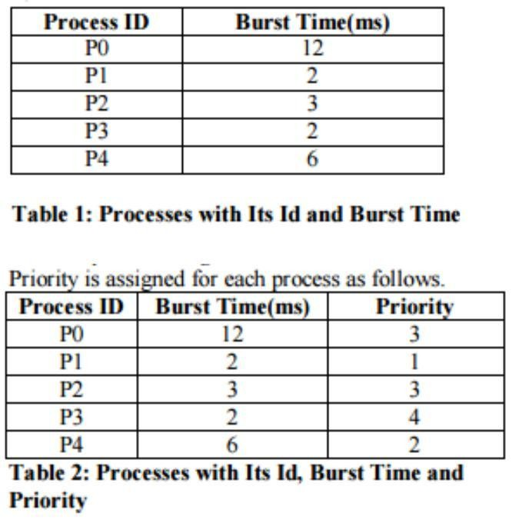

OUTPUT
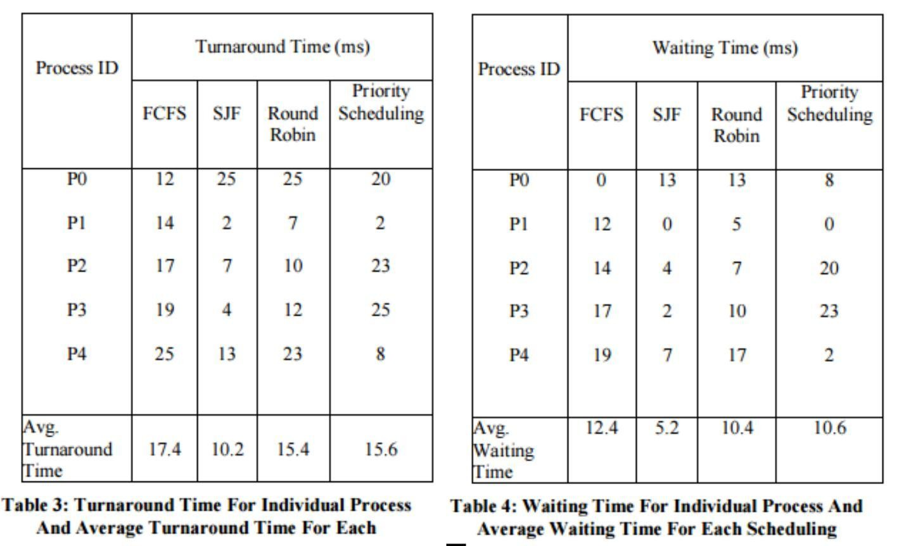

POST EXPERIMENT QUESTIONS:
Q1. The most optimal scheduling algorithm is :
a) FCFS – First come First served b) SJF – Shortest Job First
c) RR – Round Robin d) None of these.
Q2. The real difficulty with SJF in short term scheduling is:
a) It is too good an algorithm b) knowing the length of the next CPU request
c) It is too complex to understand d) None of these.
Q3. The FCFS algorithm is particularly troublesome for :
a) Time sharing systems b) multiprogramming systems
c) Multiprocessor systems d) Operating systems

LAB EXPERIMENT 2

OBJECTIVE: Implementation of Producer Consumer problem using Semaphore.
BRIEF DESCRIPTION: There is a buffer of n slots and each slot is capable of storing one unit of data. There are two processes running, namely, producer and consumer, which are operating on the buffer.

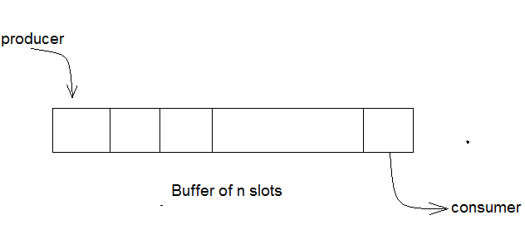

Bounded Buffer Problem
A producer tries to insert data into an empty slot of the buffer. A consumer tries to remove data from a filled slot in the buffer. As you might have guessed by now, those two processes won't produce the expected output if they are being executed concurrently.There needs to be a way to make the producer and consumer work in an independent manne

Solution
One solution of this problem is to use semaphores. The semaphores which will be used here are:
m, a binary semaphore which is used to acquire and release the lock.
empty, a counting semaphore whose initial value is the number of slots in the buffer, since, initially all slots are empty.
full, a counting semaphore whose initial value is 0.
At any instant, the current value of empty represents the number of empty slots in the buffer and full represents the number of occupied slots in the buffer.

PRE EXPERIMENT QUESTIONS:

Q1. What is a thread?

Q2. What do you mean by mutual exclusion?

Q3. What is process synchronization?

PSEUDO- CODE:

PRODUCER OPERATION:
The pseudocode of the producer function looks like this:
do {
wait(empty); // wait until empty>0 and then decrement ‘empty’
wait(mutex); // acquire lock
/* perform the insert operation in a slot */
signal(mutex); // release lock
signal(full); // increment ‘full’
} while(TRUE)

Consumer Operation
The pseudocode of the consumer function looks like this:
do {
wait(full); // wait until full>0 and then decrement ‘full’
wait(mutex); // acquire the lock
/* perform the remove operation
in a slot */
signal(mutex); // release the lock
signal(empty); // increment ‘empty’
} while(TRUE);

ALGORITHM:
Step1: Declare variable for producer & consumer as pthread-t-tid produce tid consume.
Step2: Declare a structure to add items, semaphore variable set as struct.
Step3: Read number of items to be produced and consumed.
Step4: Declare and define semaphore function for creation and destroy.
Step5: Define producer function.
Step6: Define consumer function.
Step7: Call producer and consumer.
Step8: Stop the execution.

INPUT & OUTPUT
Run both producer and consumer algorithm together using threads and display the result which ensures consumer is not going to consume the data unless producer produces.

POST EXPERIMENT QUESTIONS:
Q1. What is a semaphore? Mention its types.
Q2. What are concurrent processes?
Q3. Mention the different types of techniques which can be used to solve producer consumer
problem.

LAB EXPERIMENT 3

OBJECTIVE: To simulate the Banker's Algorithm.
ALGORITHM:
The banker’s algorithm is a resource allocation and deadlock avoidance algorithm that tests for safety by simulating the allocation for predetermined maximum possible amounts of all resources, then makes an “s-state” check to test for possible activities, before deciding whether allocation should be allowed to continue.
Following Data structures are used to implement the Banker’s Algorithm:
Let ‘n’ be the number of processes in the system and ‘m’ be the number of resources types.
Available :
- It is a 1-d array of size ‘m’ indicating the number of available resources of each type.
- Available[ j ] = k means there are ‘k’ instances of resource type R_{j}
Max :
- It is a 2-d array of size ‘n*m’ that defines the maximum demand of each process in a system.
- Max[ i, j ] = k means process P_{i} may request at most ‘k’ instances of resource type R_{j.}
Allocation :
- It is a 2-d array of size ‘n*m’ that defines the number of resources of each type currently allocated to each process.
- Allocation[ i, j ] = k means process P_{i} is currently allocated ‘k’ instances of resource type R_{j}
Need :
- It is a 2-d array of size ‘n*m’ that indicates the remaining resource need of each process.
- Need [ i, j ] = k means process P_{i} currently allocated ‘k’ instances of resource type R_{j}
- Need [ i, j ] = Max [ i, j ] – Allocation [ i, j ]
Allocation_{i} specifies the resources currently allocated to process P_{i} and Need_{i} specifies the additional resources that process P_{i} may still request to complete its task.
Banker’s algorithm consist of Safety algorithm and Resource request algorithm.

PRE EXPERIMENT QUESTIONS:
Q1.What is Deadlock?
Q2.Does Process Synchronization act as a base for Deadlock-Justify.
Q3.What is the significance of the name of the Banker’s Algorithm?

ALGORITHM:

Resource Request Algorithm:
This describes the behavior of the system when a process makes a resource request in the form of a request matrix. The steps are:
Step1: If number of requested instances of each resource is less than the need (which was declared previously by the process), go to step 2.
Step2: If number of requested instances of each resource type is less than the available resources of each type, go to step 3. If not, the process has to wait because sufficient resources are not available yet.
Step3:Now, assume that the resources have been allocated. Accordingly do,
Available = Available - Request_{i}
Allocation_{i} = Allocation_{i} + Request_{i}
Need_{i} = Need_{i} – Request_{i}
This step is done because the system needs to assume that resources have been allocated. So there will be less resources available after allocation. The number of allocated instances will increase. The need of the resources by the process will reduce. That's what is represented by the above three operations.
After completing the above three steps, check if the system is in safe state by applying the safety algorithm. If it is in safe state, proceed to allocate the requested resources. Else, the process has to wait longer.

Safety Algorithm:
Step1: Let Work and Finish be vectors of length m and n, respectively. Initially,
Work = Available
Finish[i] =false for i = 0, 1, ... , n - 1.
This means, initially, no process has finished and the number of available resources is
represented by the Available array. Find an index i such that both
Step2: Finish[i] ==false
Needi <= Work
If there is no such i present, then proceed to step 4.
It means, we need to find an unfinished process whose need can be satisfied by the available
resources. If no such process exists, just go to step 4.
Step3: Perform the following:
Work = Work + Allocation;
Finish[i] = true;
Go to step 2.
When an unfinished process is found, then the resources are allocated and the process is marked finished. And then, the loop is repeated to check the same for all other processes.
If Finish[i] == true for all i, then the system is in a safe state.
That means if all processes are finished, then the system is in safe state.
INPUT:

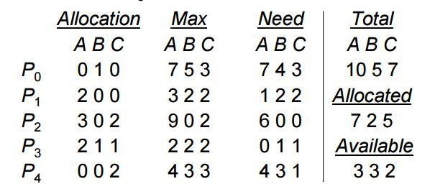

OUTPUT:
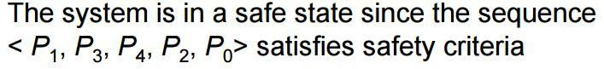
POST EXPERIMENT QUESTIONS:
Q1.What are the necessary conditions for existence of Deadlock?
Q2. Differentiate between Deadlock Avoidance & Prevention.
Q3.What is the need for Resource-Allocation Graph?

LAB EXPERIMENT 4

OBJECTIVE: To implement First fit and Best fit algorithm for memory management.
BRIEF DESCRIPTION: The memory manager is responsible for allocating primary memory to processes and for assisting the programmer in loading and storing the contents of the primary memory. Since primary memory can be space -multiplexed, the memory manager can allocate a portion of primary memory to "each process" for its own use.
Describing the strategies below:
1. Best fit: The allocator places a process in the smallest block of unallocated memory in which it will fit.
2.Worst fit: The memory manager places a process in the largest block of unallocated memory available.
3. First fit: There may be many holes in the memory, so the operating system, to reduce the amount of time it spends analyzing the available spaces, begins at the start of primary memory and allocates memory from the first hole it encounters large enough to satisfy the request.

PRE EXPERIMENT QUESTIONS:
Q1. What is memory allocation?
Q2. What is the significance of address binding?
Q3. Explain Dynamic-linking & loading?

ALGORITHM:
Step1: Start the program.
Step2: Get the segment size, number of process to be allocated and their corresponding sizes.
Step3: Get the options. If the option is ‘2’ call first fit function.
Step4: If the option is ‘1’ call best fit function. Otherwise exit.
Step5: For first fit, allocate the process to first possible segment which is free and set the slap as ‘1’. So that none of process to be allocated to segment which is already allocated and vice versa.
Step6: For best fit , do the following steps,
Step7: Sorts the segments according to their sizes.
Step8: Allocate the process to the segment which is equal to or slightly greater than the process size and set the flag as the ‘1’ .So that none of the process to be allocated to the segment which is already allocated and vice versa.
Step9: Stop the program.

INPUT:
Number of processes with their memory requirement.

OUTPUT:
Display of allocated memory for each process based on the allocation algorithm used.

POST EXPERIMENT QUESTIONS:
Q1. How does the concept of overlays help in execution of a process?
Q2. What in Contiguous Memory Allocation?
Q3. Explain Dynamic-linking & loading?
Q4. Is Logical Address Mapping to Physical Address Mapping a must-justify.

LAB EXPERIMENT 5

OBJECTIVE: To simulate page replacement algorithms: FIFO, OPTIMAL and LRU.
BRIEF DESCRIPTION: Page replacement algorithms are the techniques using which an Operating System decides which memory pages to swap out, write to disk when a page of memory needs to be allocated. Paging happens whenever a page fault occurs and a free page cannot be used for allocation purpose accounting to reason that pages are not available or the number of free pages is lower than required pages.
Reference String: The string of memory references is called reference string. Reference strings are generated artificially or by tracing a given system and recording the address of each memory reference.
PRE EXPERIMEMT QUESTIONS:
Q1. What is paging?
Q2. Is Paging a solution to the problem of external fragmentation- justify?
Q3. What is Page-Offset & Page-number?

ALGORITHM:

First in First Out (FIFO) Algorithm:
Oldest page in main memory is the one which will be selected for replacement.
Easy to implement, keep a list, replace pages from the tail and add new pages at the head.
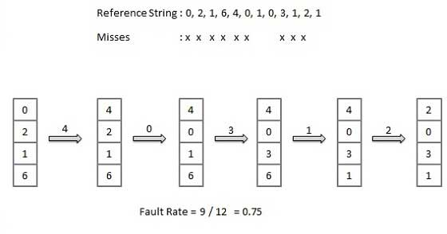

Optimal Algorithm:
An optimal page-replacement algorithm has the lowest page-fault rate of all algorithms. An optimal page-replacement algorithm exists, and has been called OPT or MIN.
Replace the page that will not be used for the longest period of time. Use the time when a page is to be used.
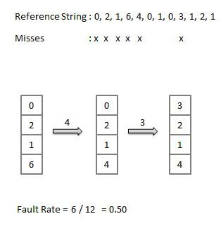
Least Recently Used (LRU) Algorithm:
Page which has not been used for the longest time in main memory is the one which will be selected for replacement.
Easy to implement, keep a list, replace pages by looking back into time.

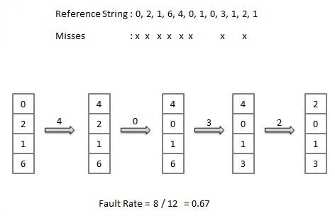

INPUT:

OUTPUT:
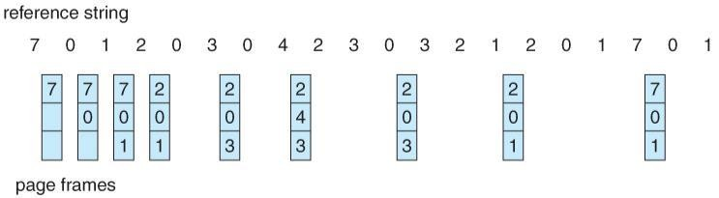
FIFO:

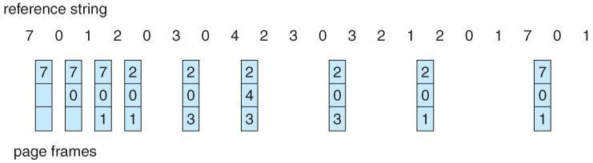
Optimal:

LRU:
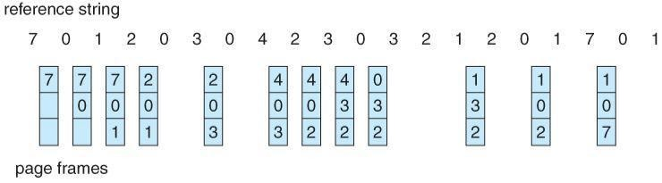

POST EXPERIMENT QUESTIONS:
Q1. Differentiate between Paging & Segmentation?
Q2. What is the effect on the performance of the Page-Replacement algorithm on changing the frame-size?
LAB EXPERIMENT 6

OBJECTIVE: To simulate the following Disk Scheduling algorithms: FCFS, SSTF, SCAN, C-SCAN, LOOK, C-LOOK.
BRIEF DESCRIPTION: Disk scheduling is is done by operating systems to schedule I/O requests arriving for disk. Disk scheduling is also known as I/O scheduling.
Disk scheduling is important because:
1. Multiple I/O requests may arrive by different processes and only one I/O request can be served at a time by disk controller. Thus other I/O requests need to wait in waiting queue and need to be scheduled.
2. Two or more request may be far from each other so can result in greater disk arm movement.
3. Hard drives are one of the slowest parts of computer system and thus need to be accessed in an efficient manner.

PRE EXPERIMENT QUESTION:
Q1. How do we formulate the basic Disk Structure?
Q2. What is the Seek Time?
Q3. What is Rotational latency?

ALGORITHM:
FCFS:
FCFS is the simplest of all the Disk Scheduling Algorithms. In FCFS, the requests are addressed in the order they arrive in the disk queue.
Every request gets a fair chance.
No indefinite postponement.
Does not try to optimize seek time.
May not provide the best possible service.
SSTF:
In SSTF (Shortest Seek Time First), requests having shortest seek time are executed first. So, the seek time of every request is calculated in advance in queue and then they are scheduled according to their calculated seek time. As a result, the request near the disk arm will get executed first. SSTF is certainly an improvement over FCFS as it decreases the average response time and increases the throughput of system.
Average Response Time decreases.
Throughput increases.
Overhead to calculate seek time in advance.
Can cause Starvation for a request if it has higher seek time as compared to incoming requests.
High variance of response time as SSTF favors only some requests.
SCAN:
In SCAN algorithm the disk arm moves into a particular direction and services the requests coming in its path and after reaching the end of disk, it reverses its direction and again services the request arriving in its path. So, this algorithm works like an elevator and hence also known as elevator algorithm. As a result, the requests at the midrange are serviced more and those arriving behind the disk arm will have to wait.
High throughput.
Low variance of response time.
Average response time.
Long waiting time for requests for locations just visited by disk arm.
C-SCAN:
In SCAN algorithm, the disk arm again scans the path that has been scanned, after reversing its direction. So, it may be possible that too many requests are waiting at the other end or there may be zero or few requests pending at the scanned area.
These situations are avoided in CSAN algorithm in which the disk arm instead of reversing its direction goes to the other end of the disk and starts servicing the requests from there. So, the disk arm moves in a circular fashion and this algorithm is also similar to SCAN algorithm and hence it is known as C-SCAN (Circular SCAN).
Provides more uniform wait time compared to SCAN.
LOOK:
It is similar to the SCAN disk scheduling algorithm except the difference that the disk arm in spite of going to the end of the disk goes only to the last request to be serviced in front of the head and then reverses its direction from there only. Thus it prevents the extra delay which occurred due to unnecessary traversal to the end of the disk.
C-LOOK:
As LOOK is similar to SCAN algorithm, in similar way, CLOOK is similar to CSCAN disk scheduling algorithm. In CLOOK, the disk arm inspite of going to the end goes only to the last request to be serviced in front of the head and then from there goes to the other end’s last request. Thus, it also prevents the extra delay which occurred due to unnecessary traversal to the end of the disk.
Each algorithm is unique in its own way. Overall Performance depends on number and type of requests.

INPUT:
Queue: 95,180, 34,119,11,123,62,64 with read write head initially at track 50 and the tail track being at 199

OUTPUT:

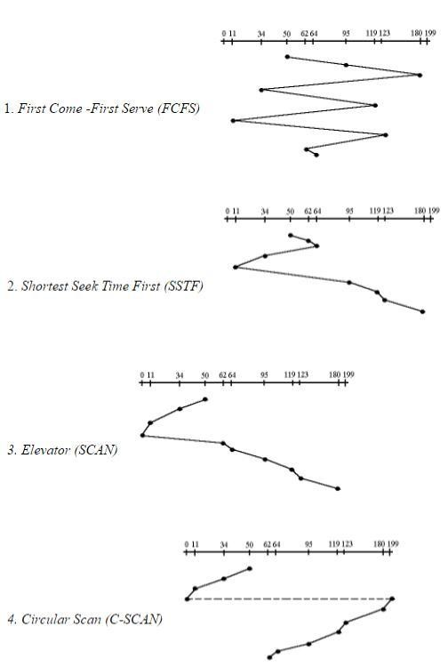

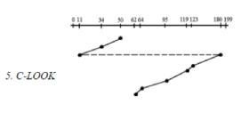
POST EXPERIMENT QUESTIONS:
Q1. What is the importance & need of Disk Scheduling?
Q2. What are the factors that decide algorithmic evaluation of Disk Scheduling?
Q3. What is Disk Management?

This lab manual has been prepared by

Dr. Sukhendra Singh
sukhendrasingh@jssaten.ac.in

Please spare some time to provide your valuable feedback

